

**User Guide**

**SITE NAME: Stebilex**

**CREATED ON: 05/Jun/2018**

# Table of Contents

Table of Contents 2

1. Website Login 3

2. Theme/Site options 4

Customize 4

General Options 5

Website Menu Management 8

Homepage 10

About Us Page 19

Services Page 22

Contact Us Page 26

Solutions Detail Page 30

General Settings 32

# Website Login

|  |  |
| --- | --- |
| **Site URL** | http://stebilex.com/ |
| **Admin URL** | http://stebilex.com/wp-admin/ |
| **Username** | usrstebadmx |
| **Password** | bU#lRDrT(x0!mD#HC0 |

# Theme/Site options

This section will help you with information on the **basic/common settings** of the website including logo, favicon, menu , widgets etc.

## Customize

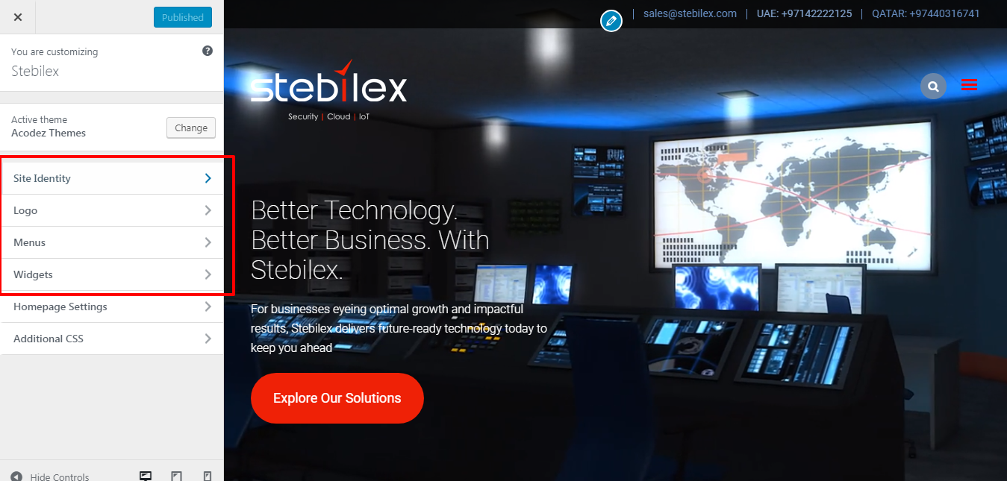

**Path:**Backend of website >> Appearance >>Customize

Here you can edit the logo, favicon, site title, site description etc. Once you have done the changes, you can save the same by clicking the Blue button (Save) on the top of the screen.

## General Options

**Frontend**

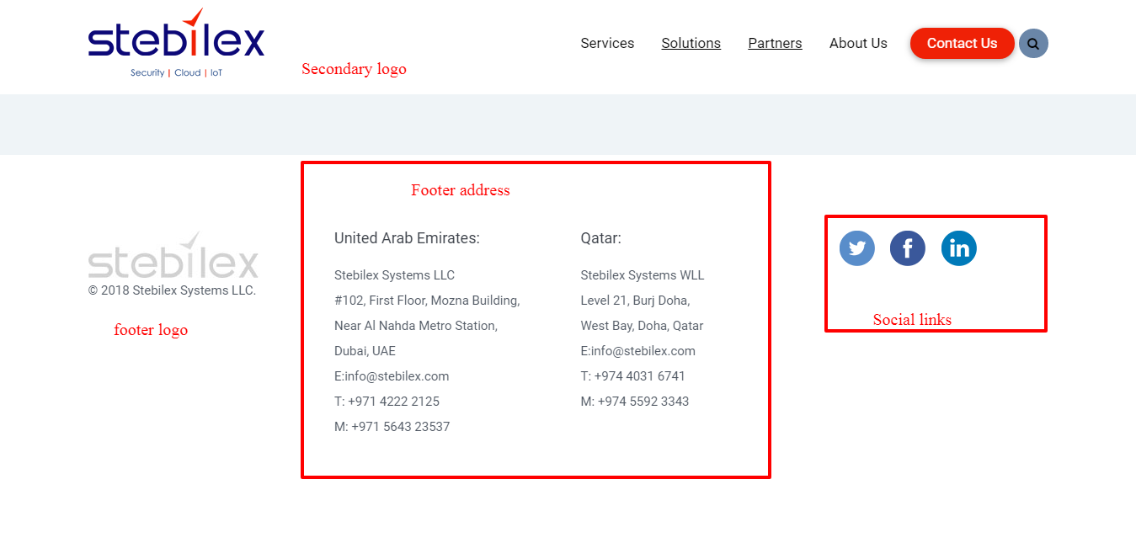

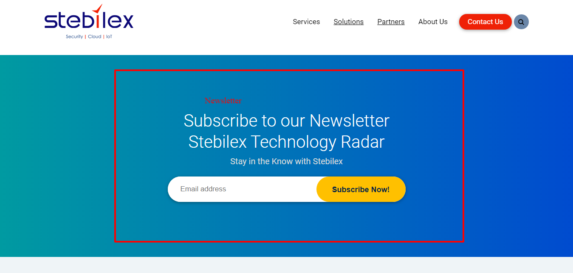

**Backend**

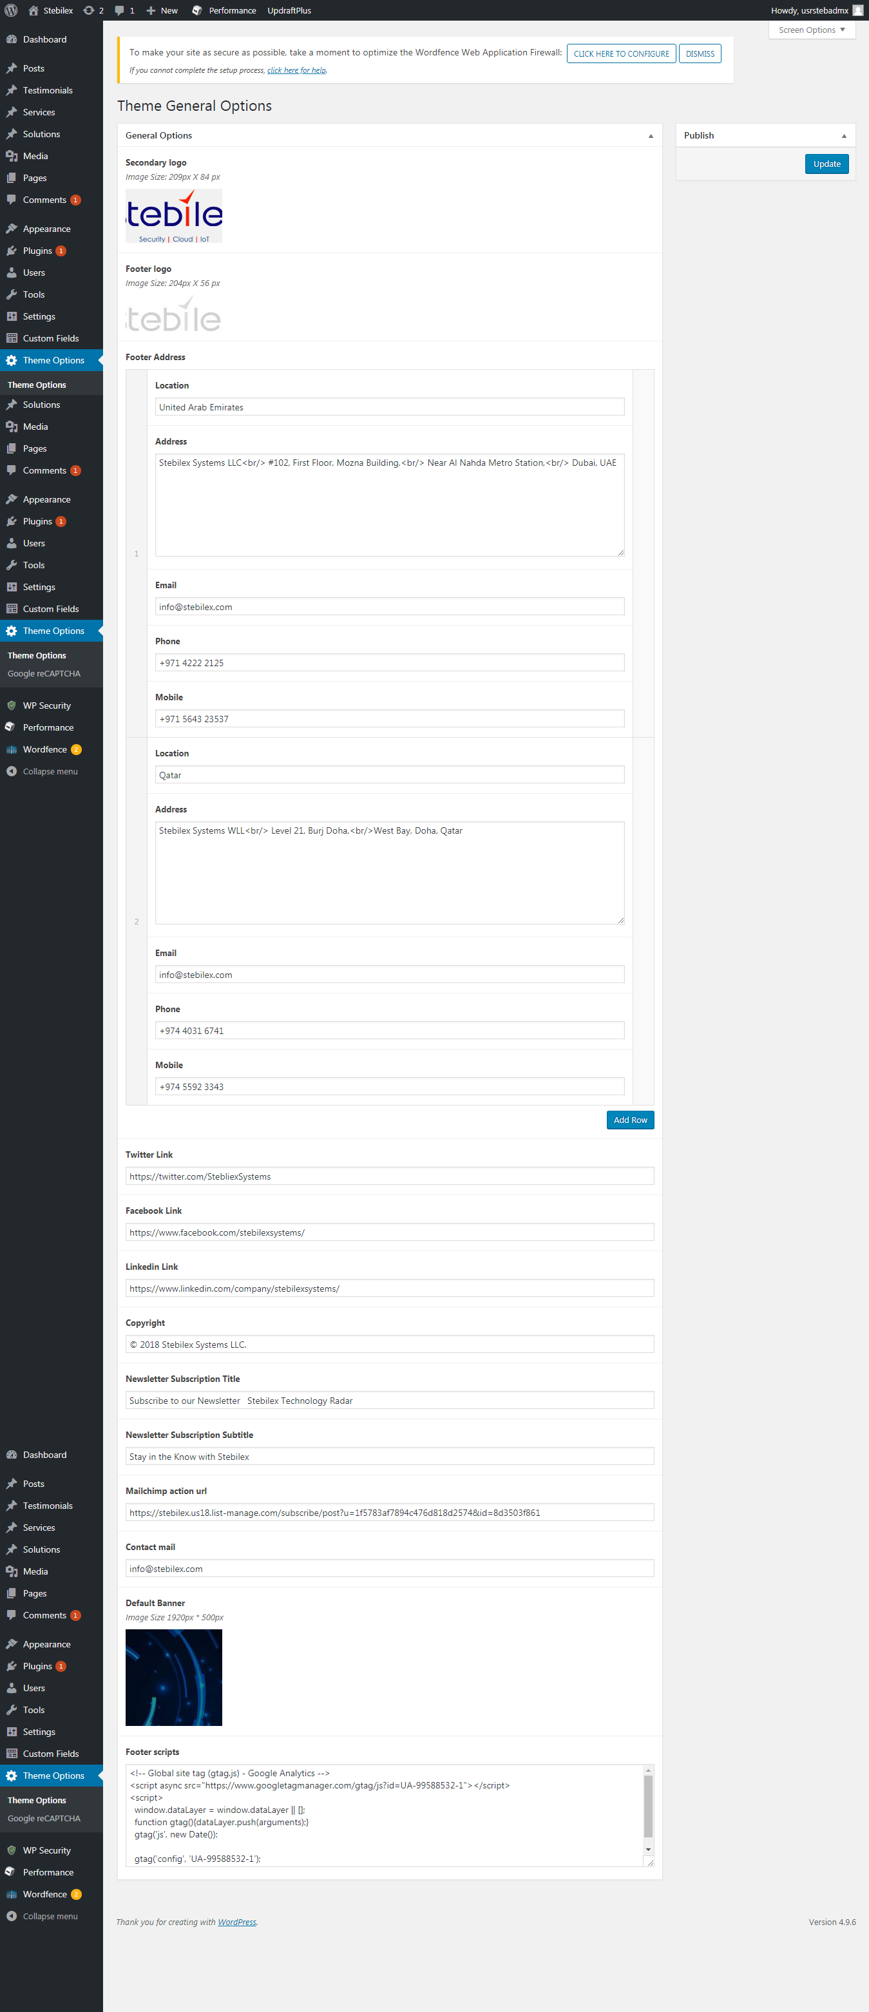

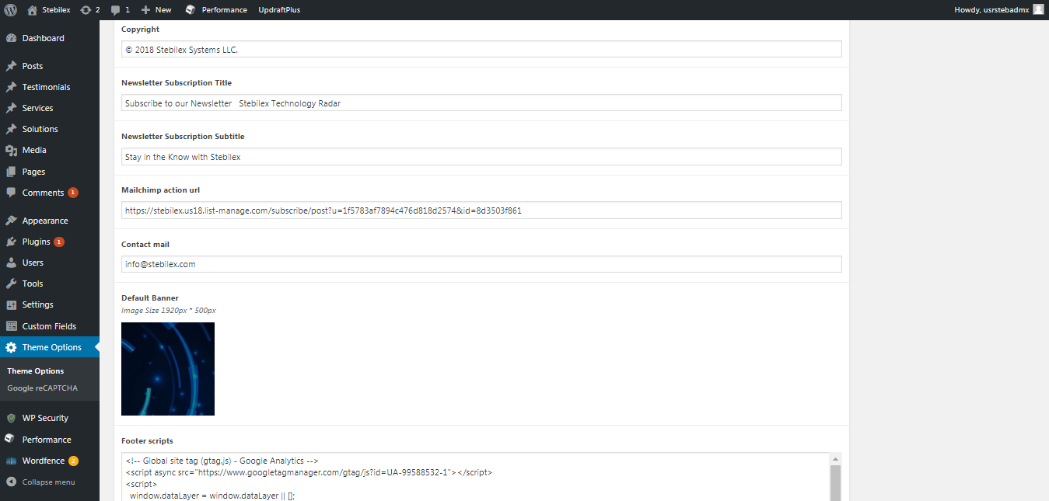

**Path:**Backend of website >> Appearance >> Theme Options >>Theme Options

Recaptcha keys for contact form



**Path:**Backend of website >> Appearance >> Theme Options >>Google reCAPTCHA

## Website Menu Management

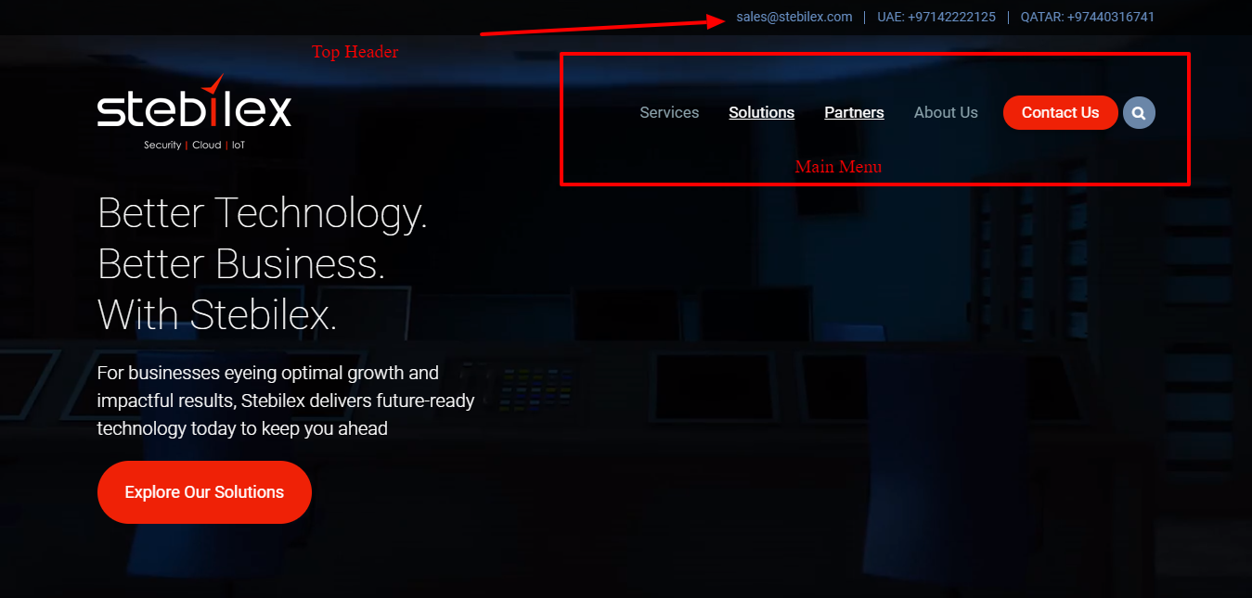

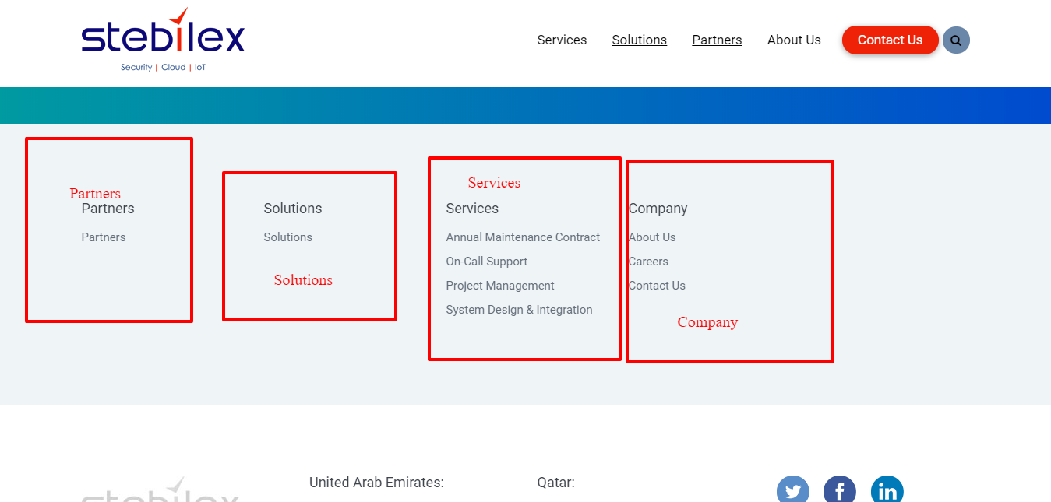

Path: Appearance=>Menus

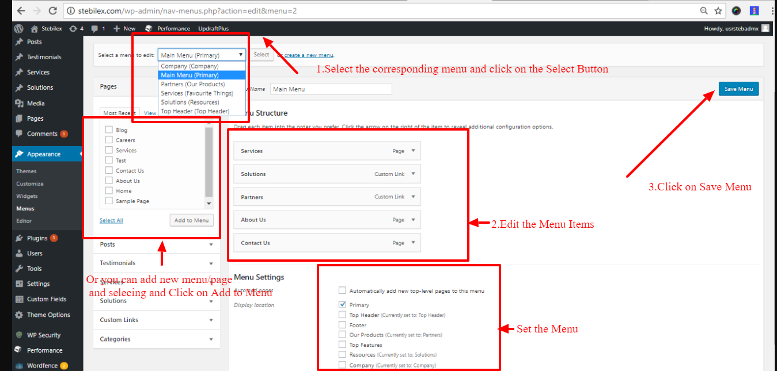

# Homepage

## Homepage Settings

Path: Pages->All Pages ->Home

` 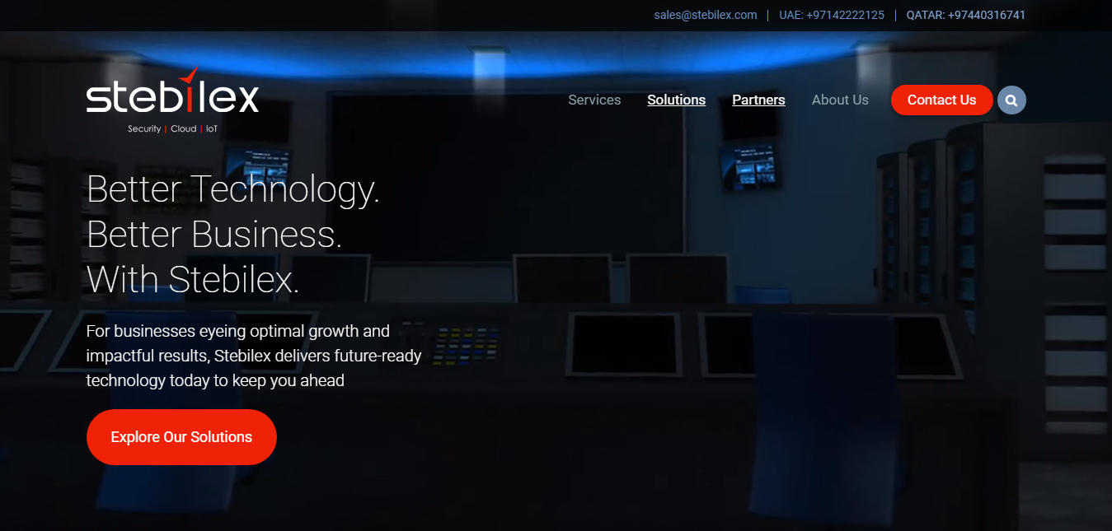

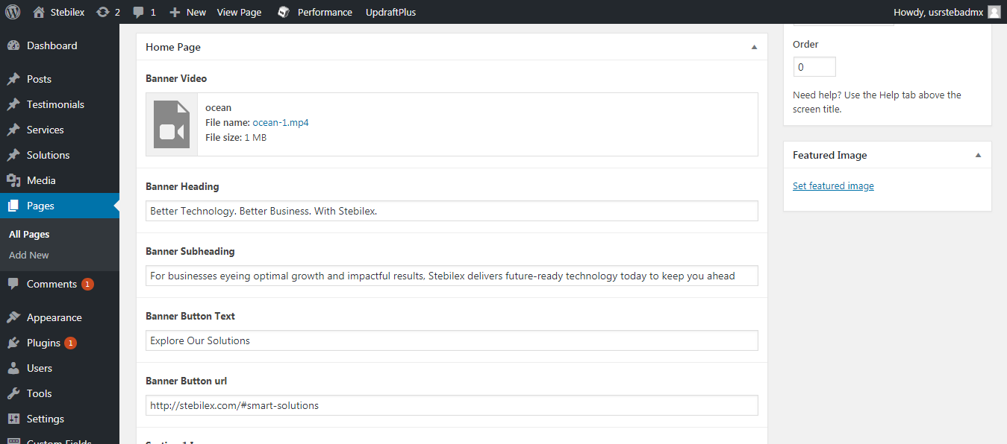



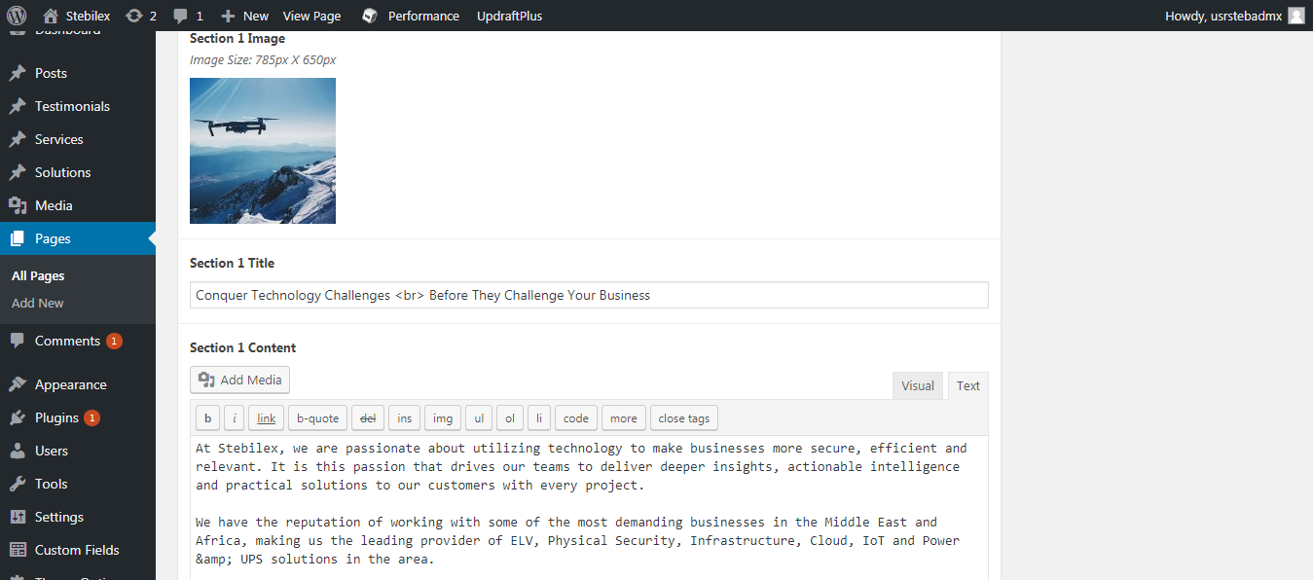

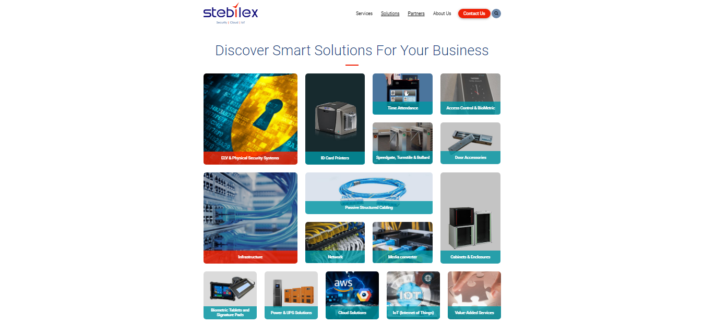

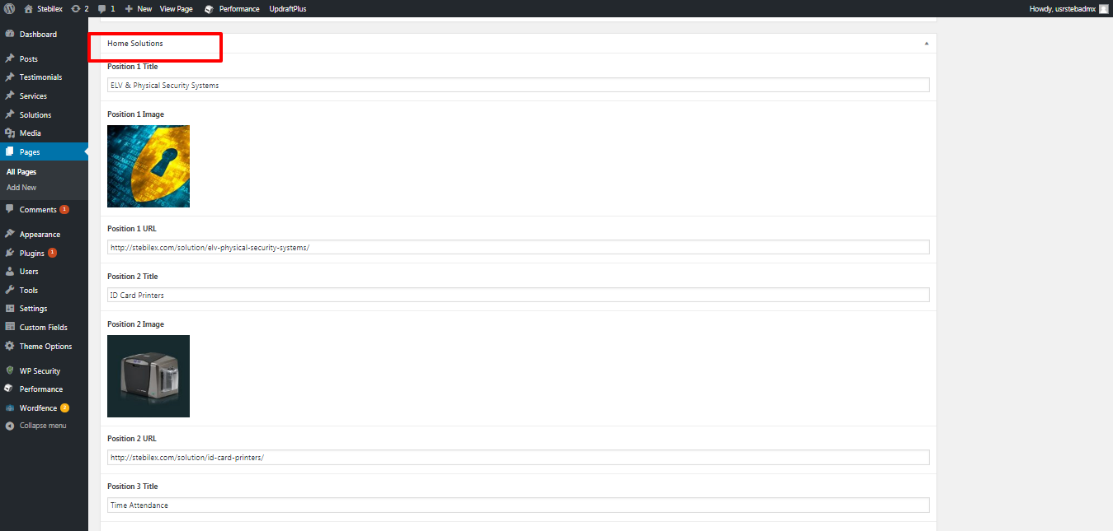

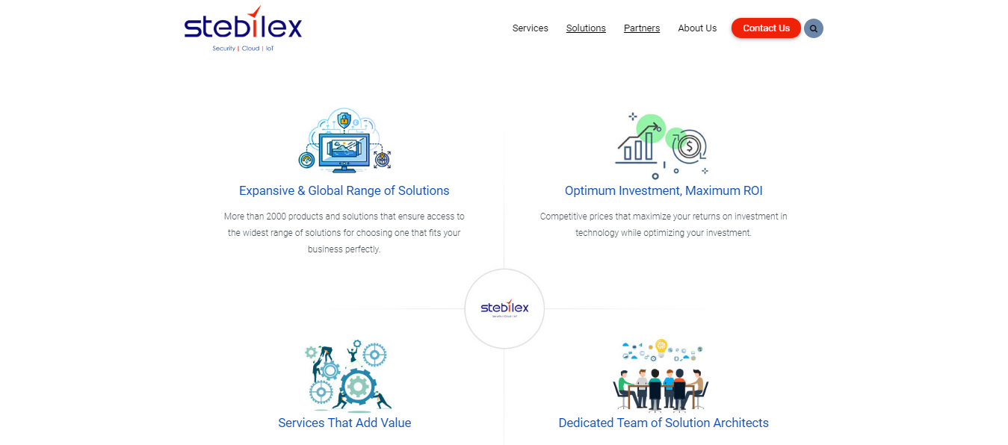

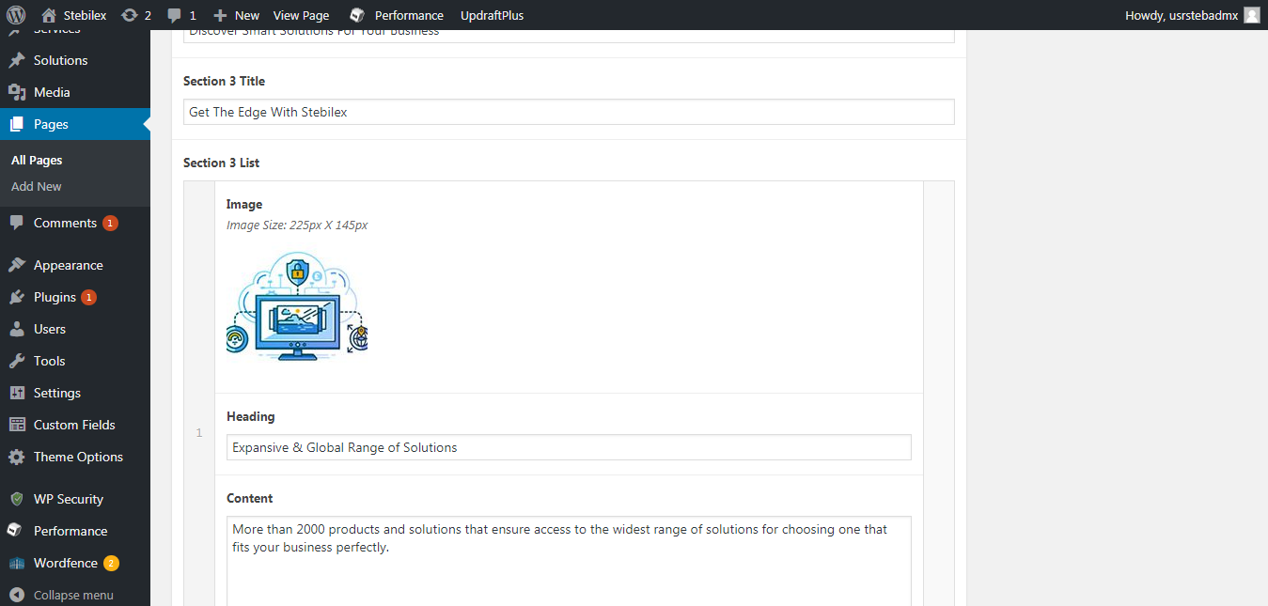



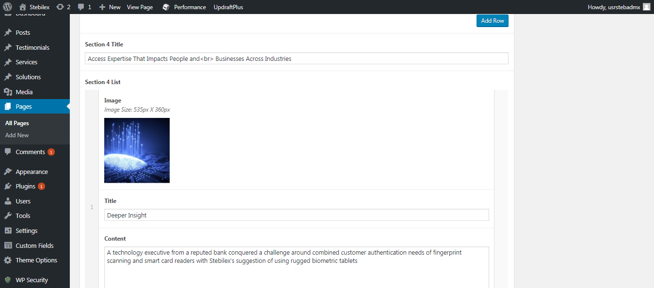



Path :admin =>Testimonials=>All Items

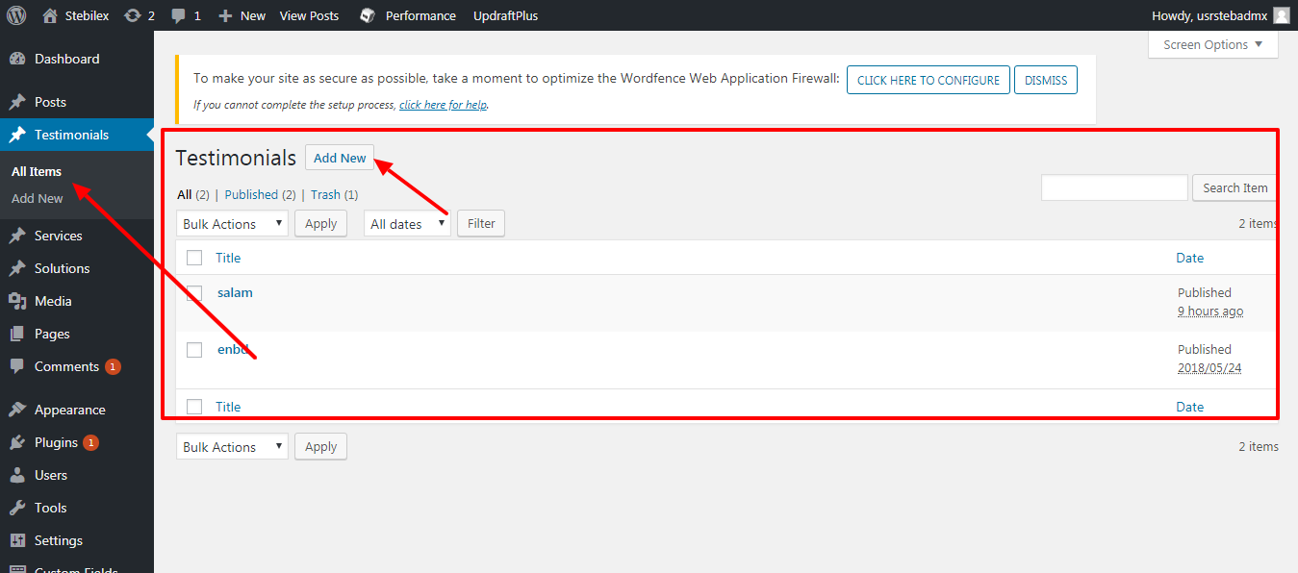

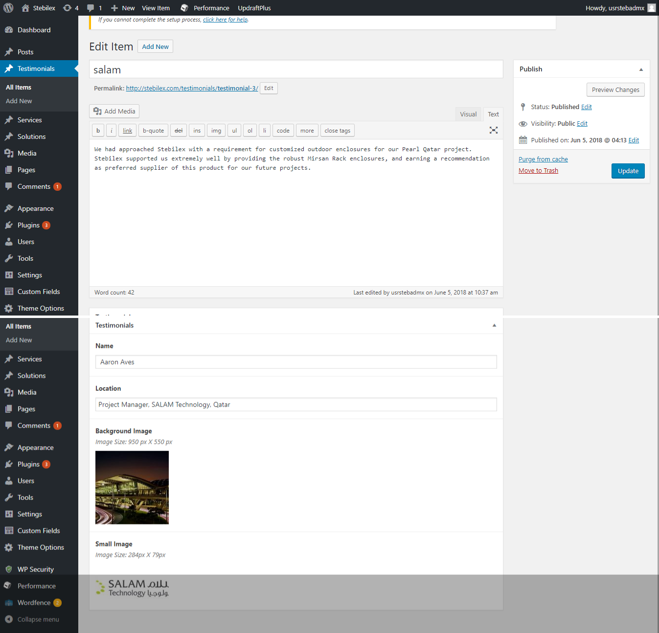



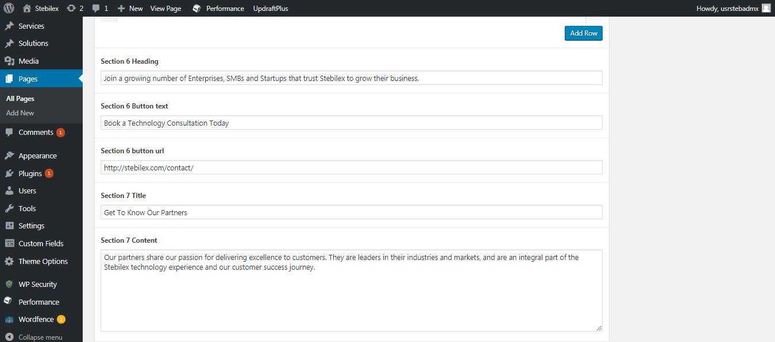

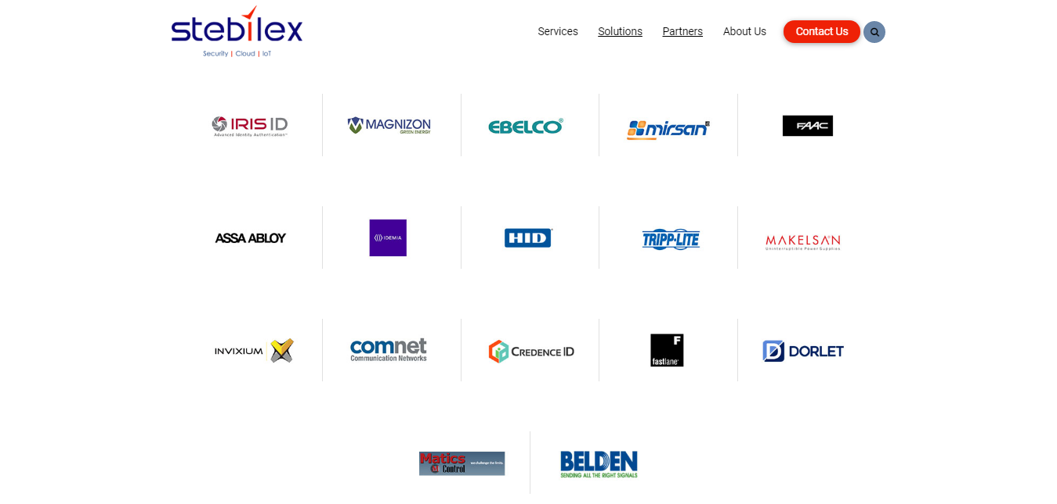

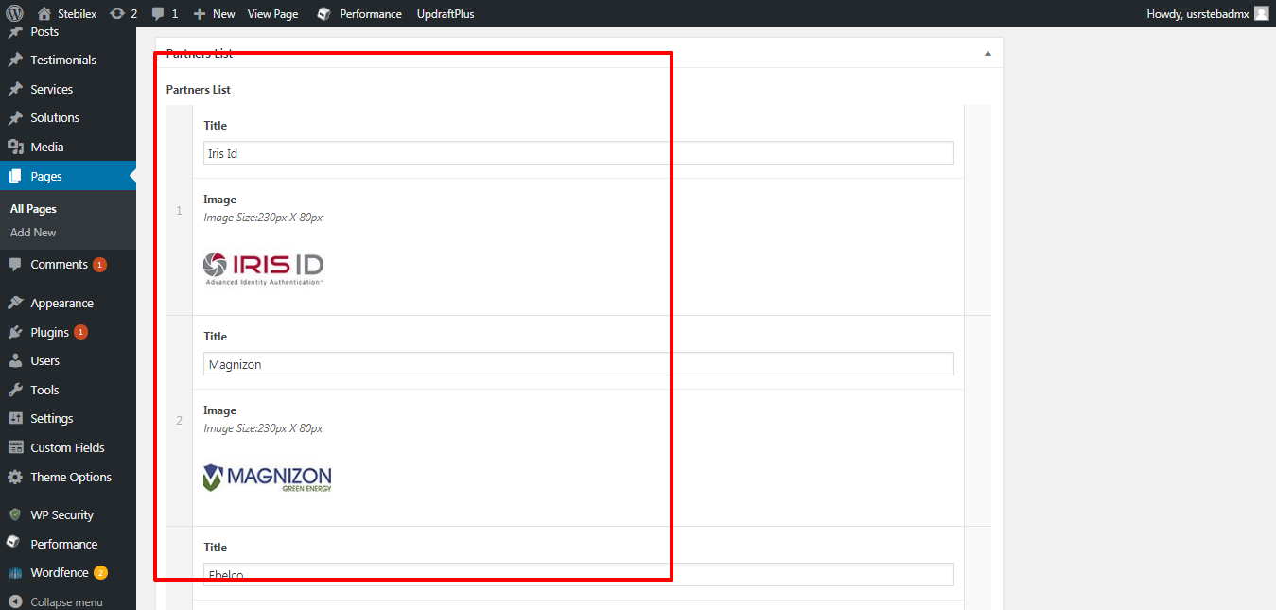

After editing,Click on **Update** button at top right to save the changes

# About Us Page

**About Us Settings**

Path: Pages->All Pages ->About Us

After editing the content ,Click on **Update** button at top right to save the changes

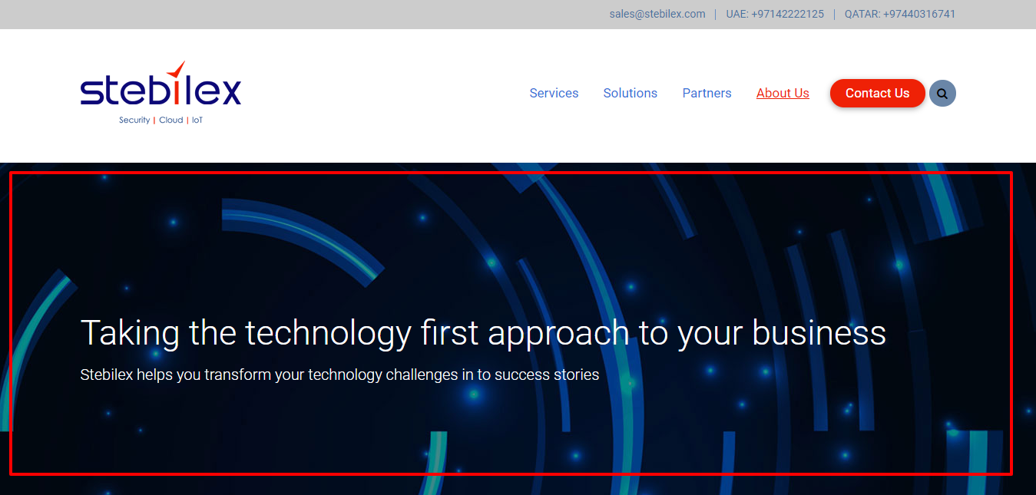

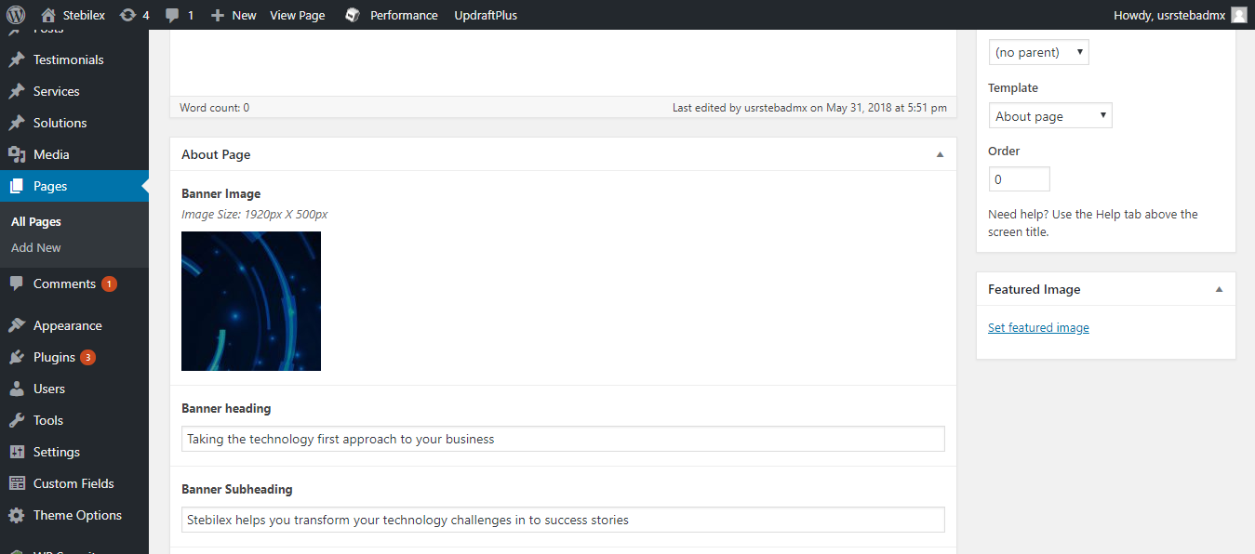

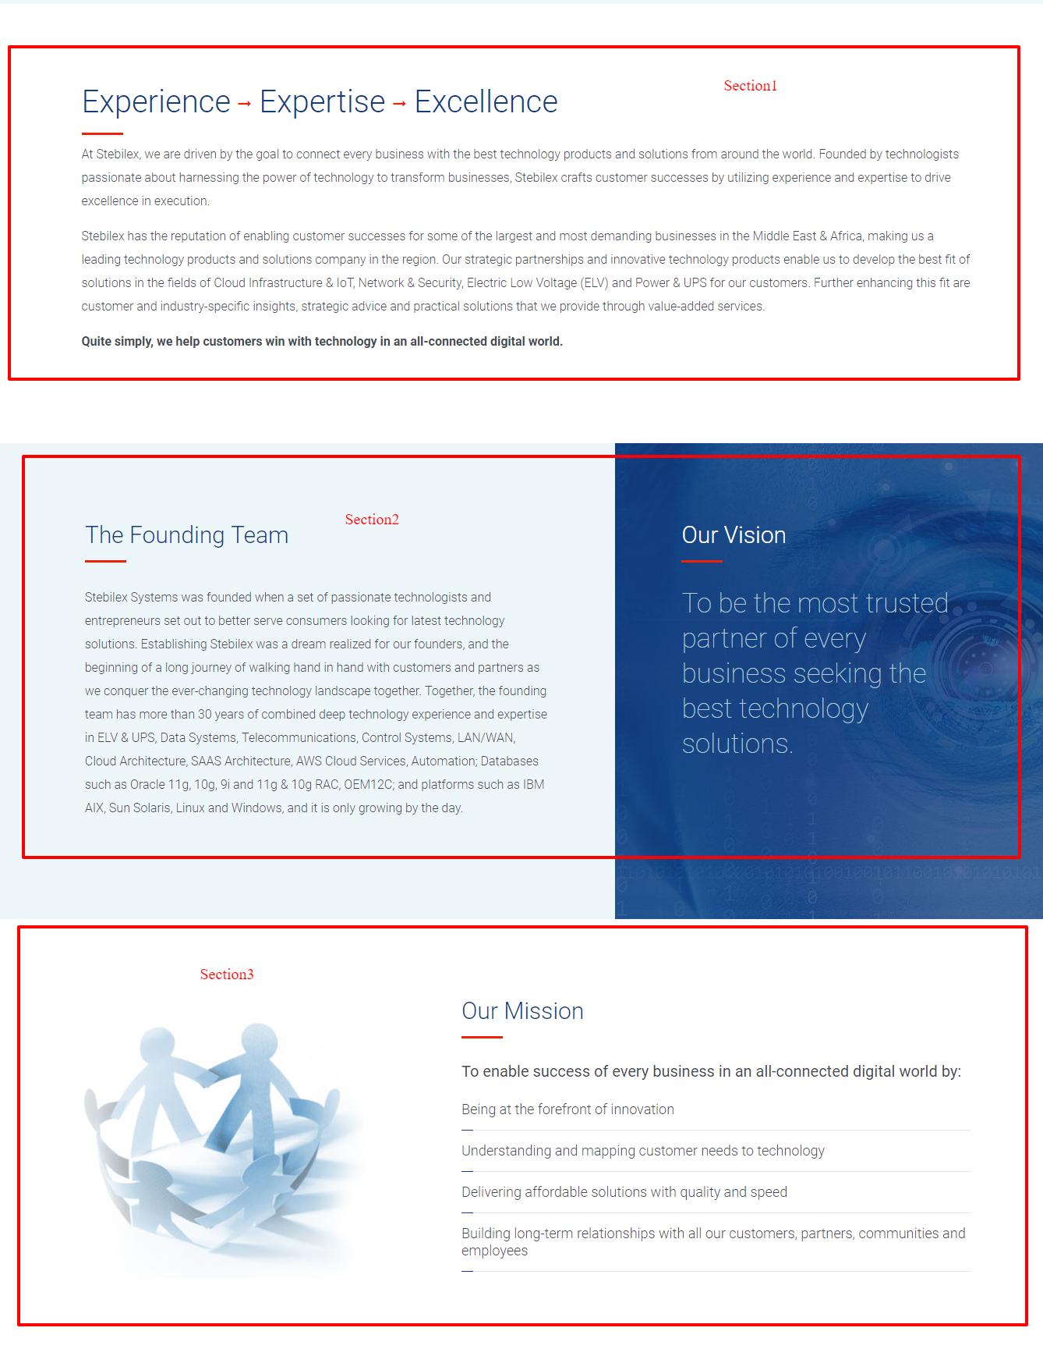

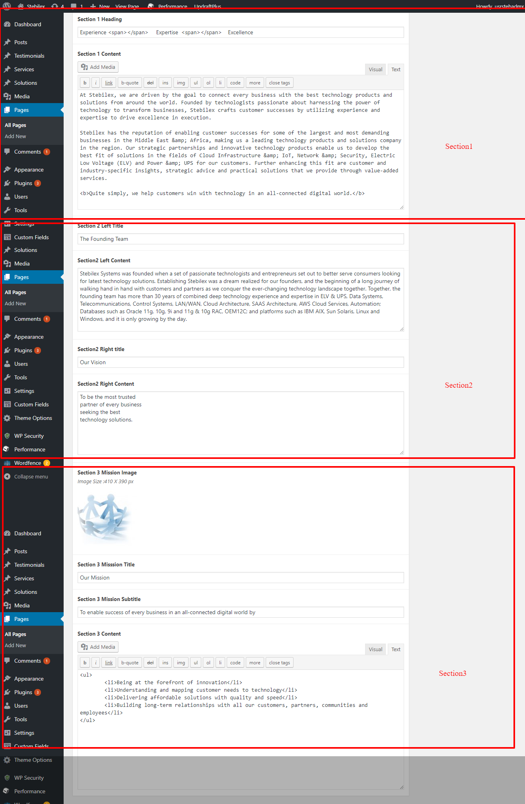

# Services Page

**Service Page Settings**

Path:Pages->All Pages->Services

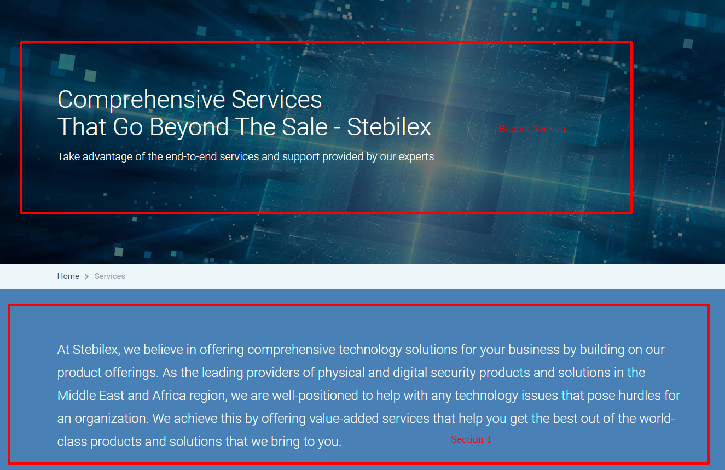

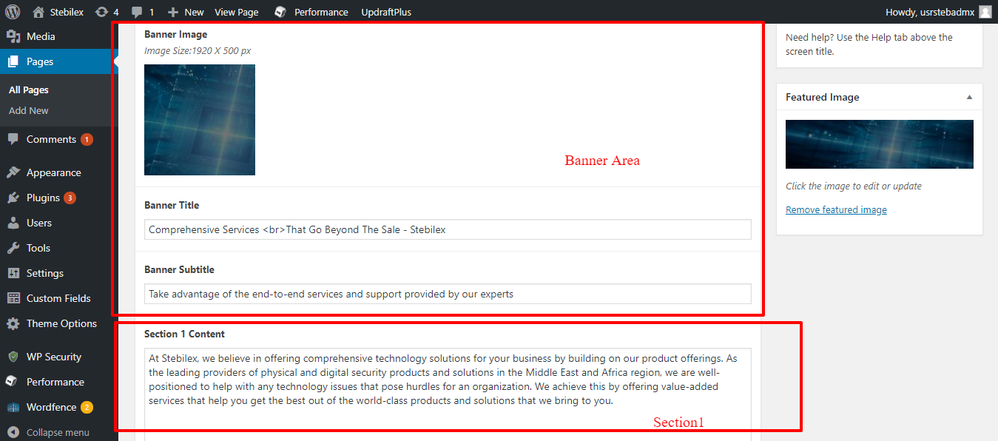

After editing the content ,Click on **Update** button at top right to save the changes

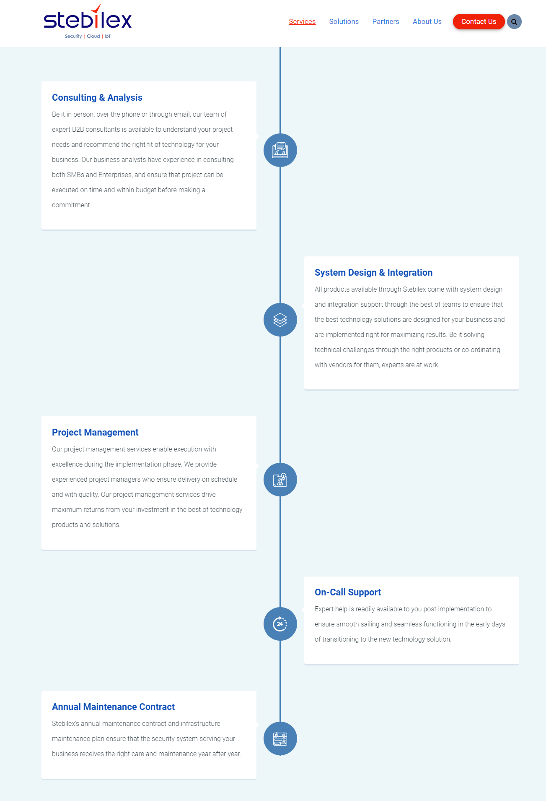

Path:Services=>All Items

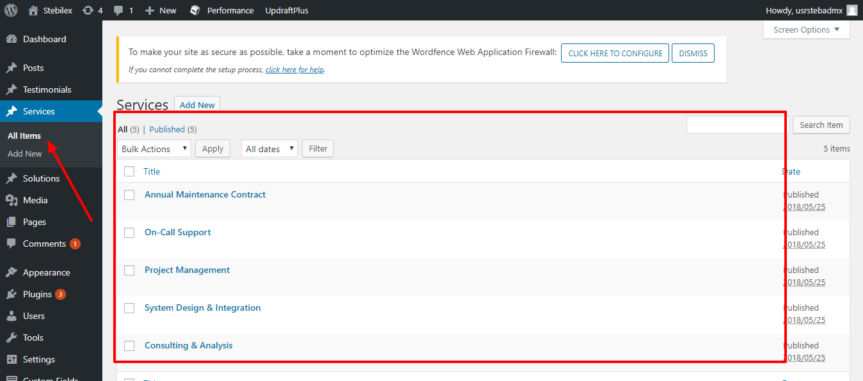

Clicking on corresponding service,the following page will appear

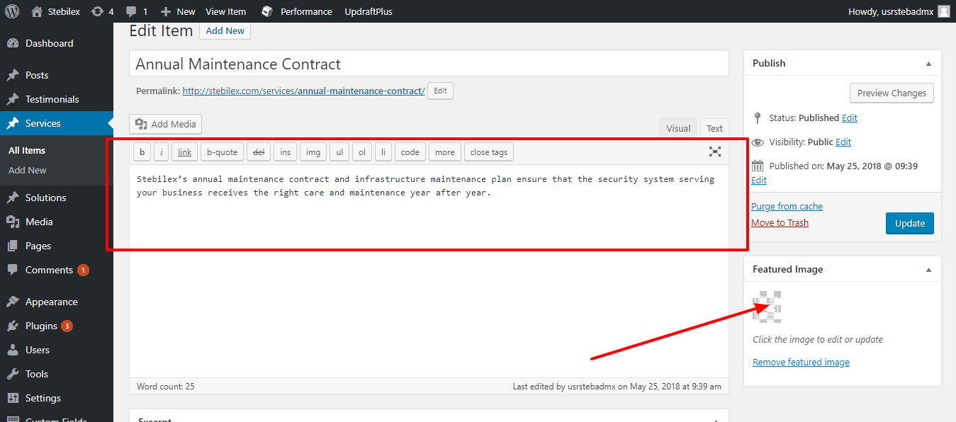

After editing the content ,Click on **Update** button at top right to save the changes

# Contact Us Page

**Contact Page Settings**

Path : Pages=>All Pages=> Contact Us

After editing the content ,Click on **Update** button at top right to save the changes

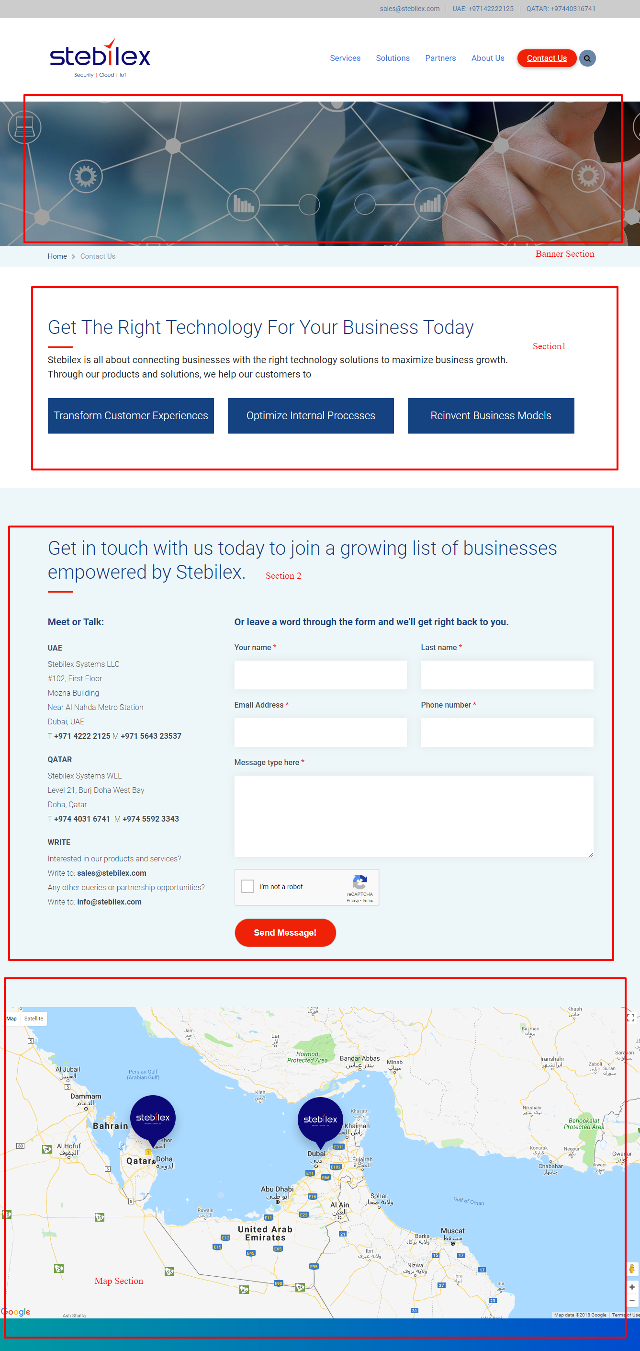

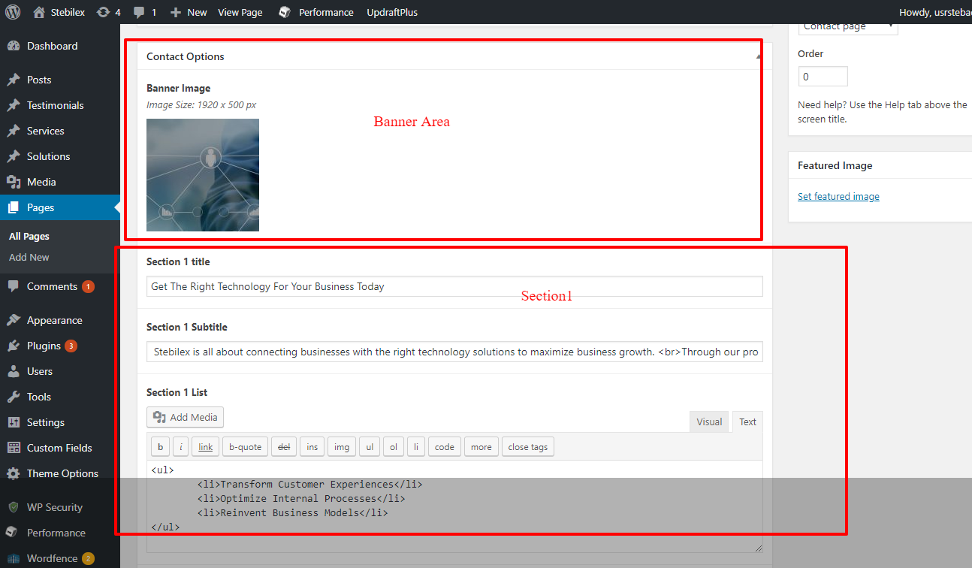

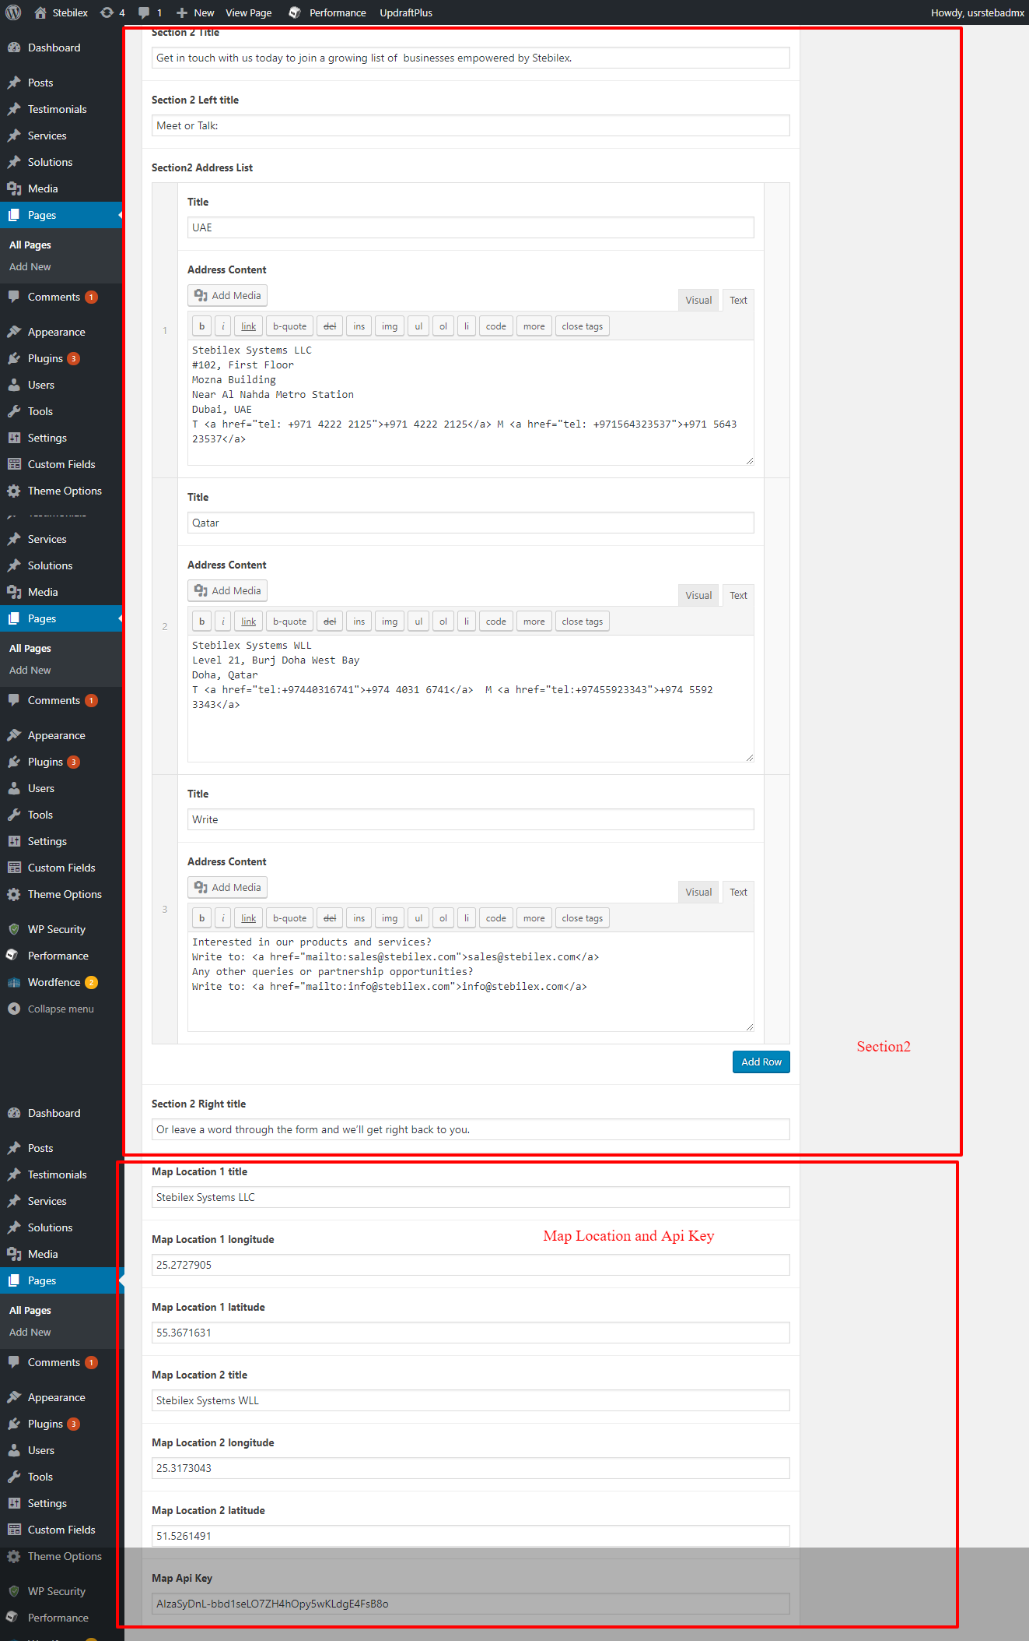

# Solutions Detail Page

**Solutions Details Settings**

In order to Add/Edit Solutions

Path : Solutions=>Add Items

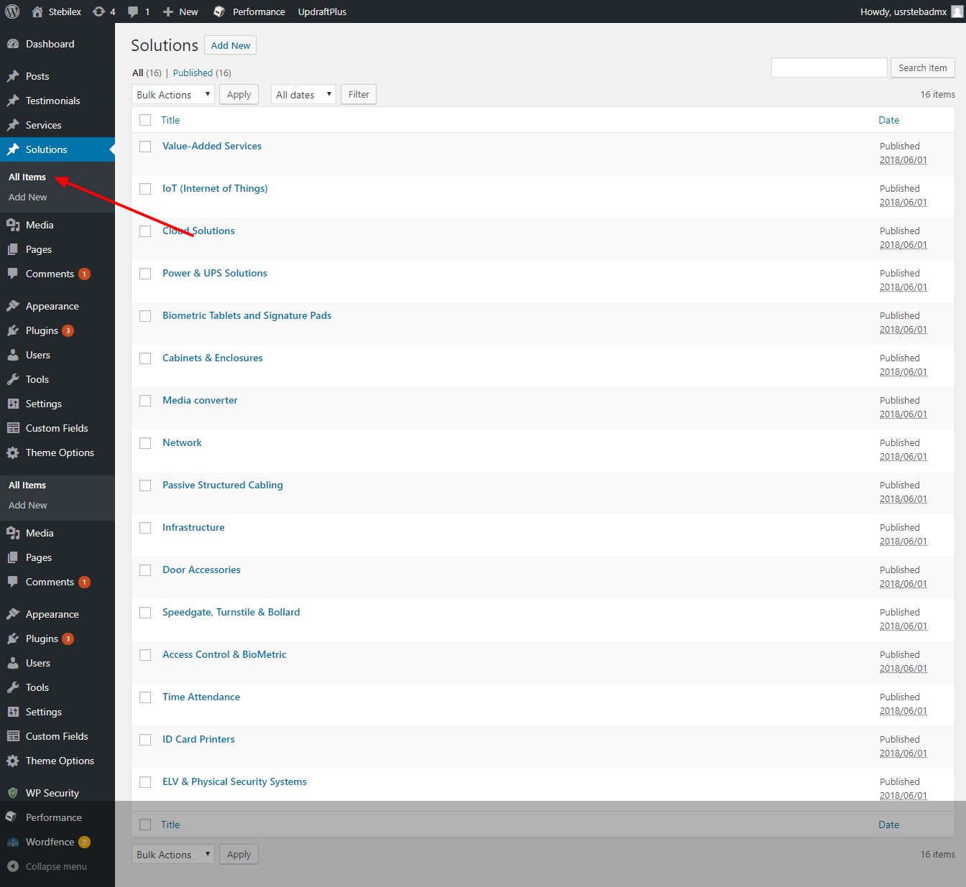

To edit click on corresponding solutions,

On the page appears, add the content on the content area and Click on **Update** button at top right to save the changes.

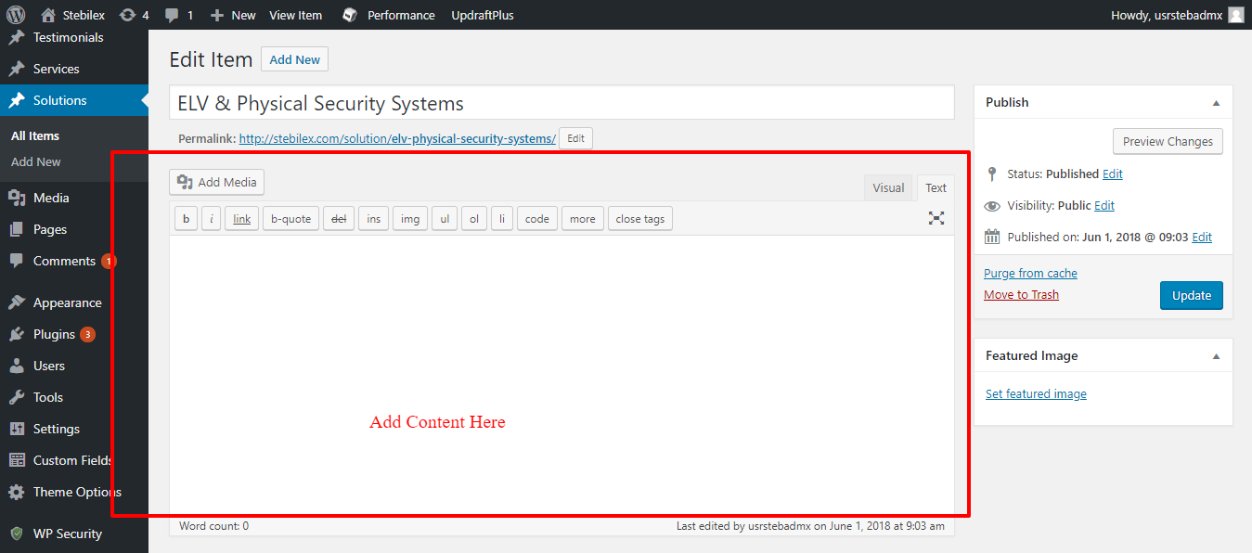

**General Settings**

Whenever you do any changes,Please clear the cache for better results.To do this

Path:**Performance=>Dashboard**

Click on **empty all caches**

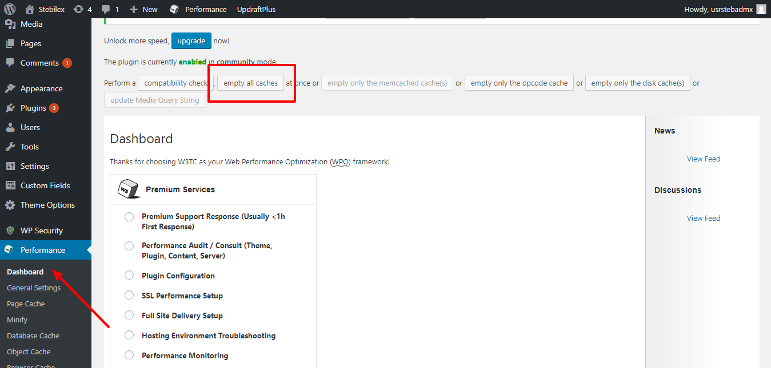

**-Thank You-**